**DIGITAL LOCK WITH HOME AUTOMATION**

**for**

**CSE-2006 Microprocessor and Interfacing**

**by**

* **Aryan Arora 19BCE1479**
* **Ayush Dhiman 19BCE1463**
* **Harsh Vardhan 19BCE1661**

A project report submitted to

**Dr SASITHRADEVI. A**



**Vandalur – Kelambakkam Road**

**Chennai – 600127**

**NOVEMBER 2020**

**BONAFIDE CERTIFICATE**

Certified that this project report entitled “**DIGITAL LOCK WITH HOME AUTOMATION USING ARDUINO”** is a bonafide work of Aryan Arora 19BCE1479**, Ayush Dhiman 19BCE1463, Harsh Vardhan 19BCE1661 who** carried out the Project work under my supervision and guidance for **CSE-2006 Microprocessor and**

**Interfacing**

**Dr SASITHRADEVI A**

Associate Professor

School of Electronics Engineering (SENSE),

VIT University, Chennai

Chennai – 600 127.

**ABSTRACT**

**In this project, we propose a smart digital door lock system for home** automation. A digital door lock system is an equipment that uses password as the method for authentication instead of the legacy key system. The door lock system proposed here consists of *Keypad* for user authentication, *LCD* for display, *servo motor* module for opening and closing of the door, a *buzzer* to alert when the door is opened and closed and finally an LED which switches on the moment the correct password is entered.

The biggest advantage of our proposed system over existing ones is that it can be easily installed when and where necessary without requirement of any infrastructures and proper planning.

**ACKNOWLEDGEMENT**

We wish to express our sincere thanks and deep sense of gratitude to our project guide, **Dr. Sasithradevi A,** Associate Professor, School of Electronics Engineering, for her consistent encouragement and valuable guidance offered to us in a pleasant manner throughout the course of the project work.

We also take this opportunity to thank all the faculty of the School for their support and their wisdom imparted to us throughout the course.

We thank our parents, family, and friends for bearing with us throughout the course of our project and for the opportunity they provided us in undergoing this course in such a prestigious institution.

**TABLE OF CONTENTS**

|  |  |  |  |
| --- | --- | --- | --- |
| **SERIAL NO.** |  | **TITLE** |  |
|  |  | ABSTRACT |  |
|  |  | ACKNOWLEDGEMENT |  |
|  |  |  |  |
| 1 |  | INTRODUCTION |  |
|  |  |  |  |
|  | 1.1 | OBJECTIVES |  |
|  | 1.2 | APPLICATIONS  & FEATURES |  |
|  |  |  |  |
|  |  |  |  |
| 2 |  | DESIGN |  |
|  | 2.1 | BLOCK DIAGRAM |  |
|  | 2.2  2.3 | CIRCUIT DIAGRM  HARDWARE COMPONENTS |  |
|  |  |  |  |
| 3 | 3.1 | SOFTWARE –CODING AND ANALYSIS |  |
|  | 3.2 | FULL CODE |  |
| 4 |  |  |  |
|  | 4.1 | CONCLUSION |  |
|  | 4.2 | FUTURE WORK |  |

5 REFERENCES

1. **INTRODUCTION**

Often, we need to secure a room at our home or office so that no one can access the room without our permission and ensure protection against theft or loss of our important accessories and assets. There are so many types of security systems present today but behind the scenes, for authentication they all relay on fingerprint, retina scanner, iris scanner, face id, tongue scanner, RFID reader, password, pin, patterns, etc.

Off all the solutions the low-cost one is to use a password or pin-based system. So, in this project, we have built an Arduino Keypad Door Lock which can be mounted to any of your existing doors to secure them with a digital password.

**1.1 OBJECTIVES**

Security is a major concern in our day-to-day life, and digital locks have become an important part of these security systems and home automation is used to make life easier.

Therefore, implementing these both into a digital code lock is imitated in this project using Arduino board and a matrix keypad.

**1.2 APPLICATIONS & FEATURES**

This system can be used as a home lock system which takes a password as input instead of keys. It can also be used to secure small cabinets wardrobes etc.

It integrates with all the lighting in the house and can be calibrated to turn on the lights when the person enters the correct pin and enters the house. If an incorrect password the buzzer present will buzz and alert the residents about the same.

1. **DESIGN**
   1. **BLOCK DIAGRAM**

**VIDEO IMPLEMENTAION**

<https://drive.google.com/drive/folders/1itetbOOLUXKuYhQi7NM1tFrftVyEgeVY?usp=sharing>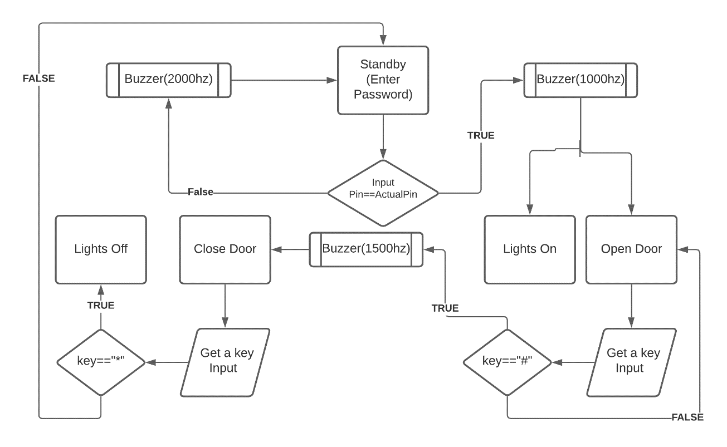

* 1. **CIRCUIT DIAGRAM**

<https://www.tinkercad.com/things/hDJkfGfHuxg-arduino-door>

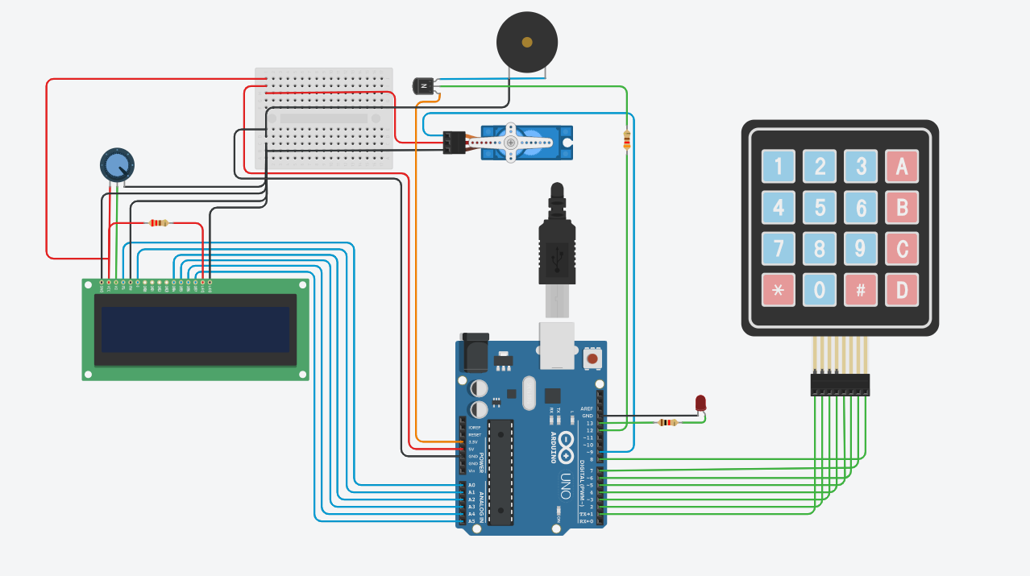

* 1. **HARDWARE COMPONENTS**
* Arduino Uno

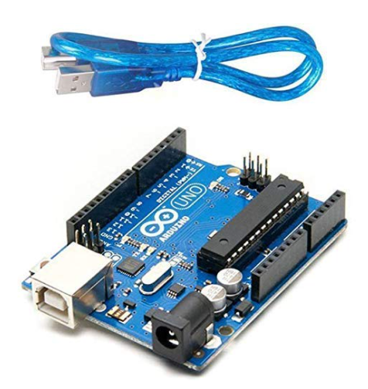

* 16*2 Lcd Display

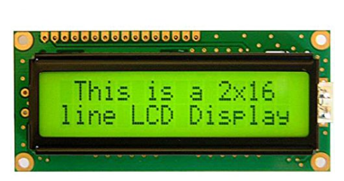

* 4*4 matrix keypad

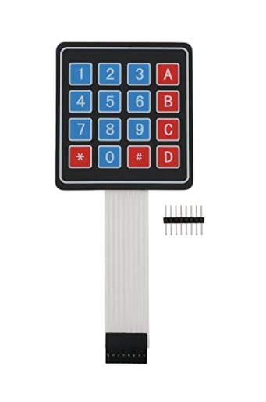

* TowerPro SG 90 Micro Servo Motor

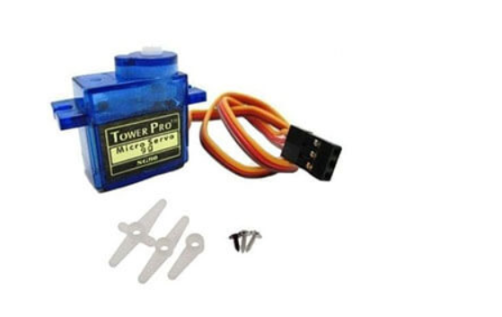

* 10k Ohm Potentiometer Single Variable Resistor

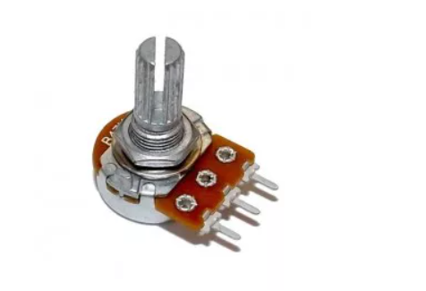

* 330ohm Resistor

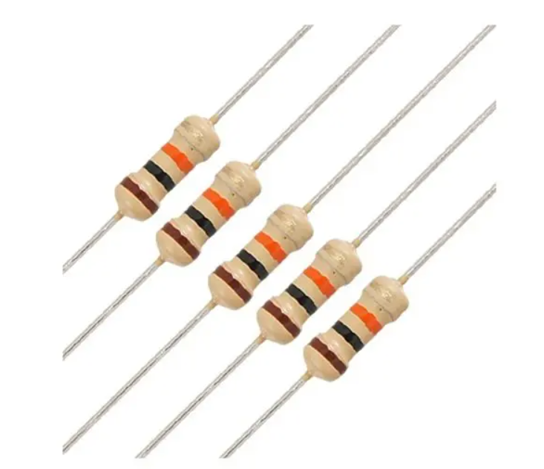

* Universal Buzzer

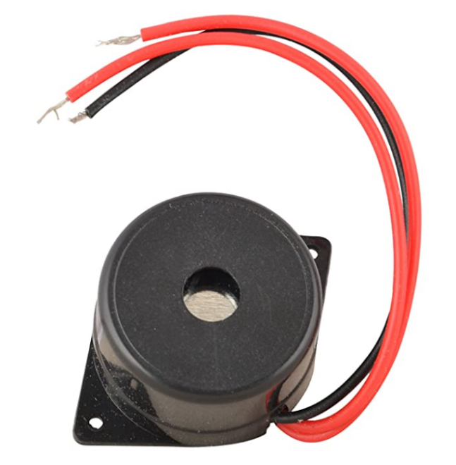

* LED

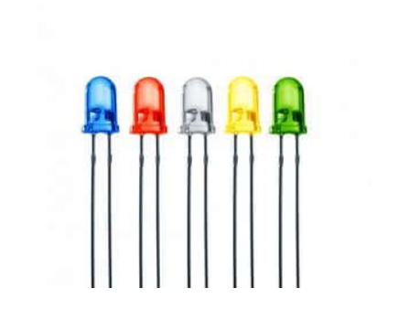

* 40 Pins Male Berg Strip Connector Header Pin

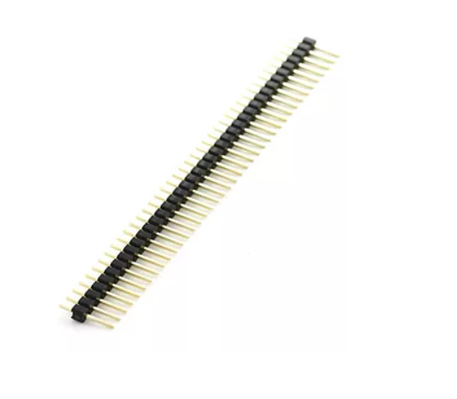

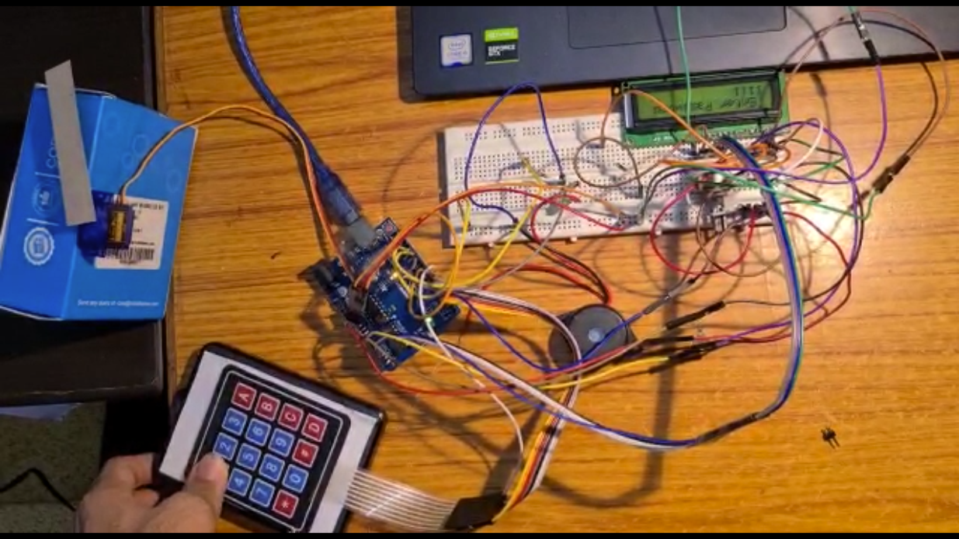

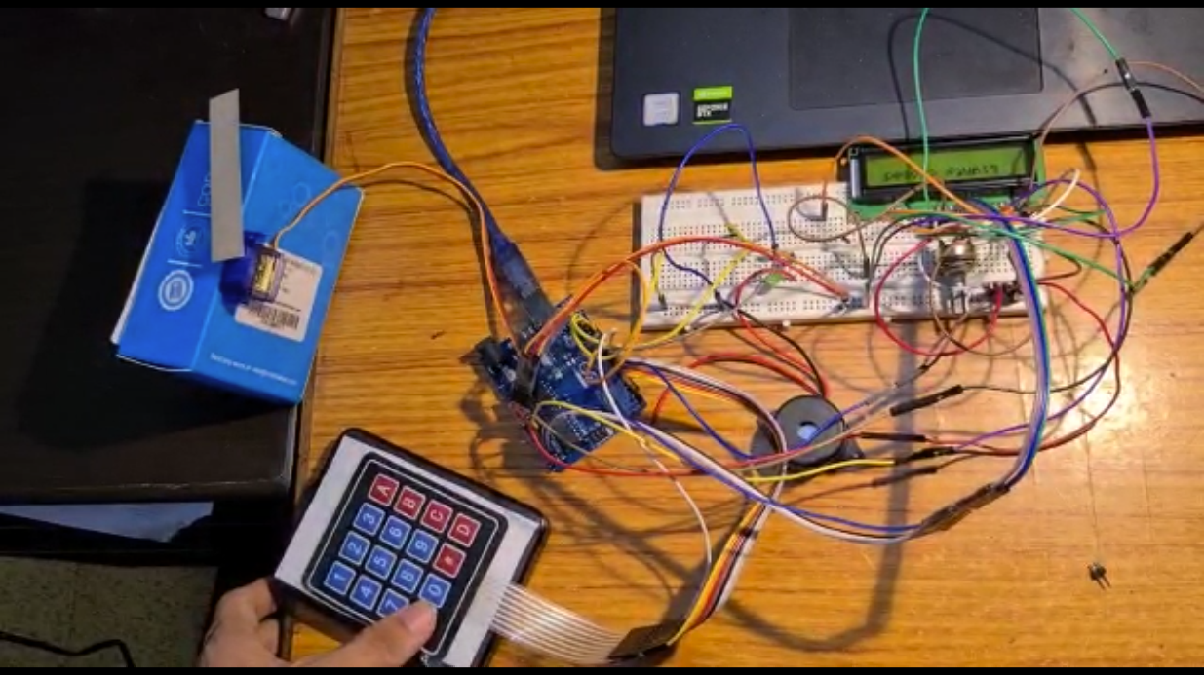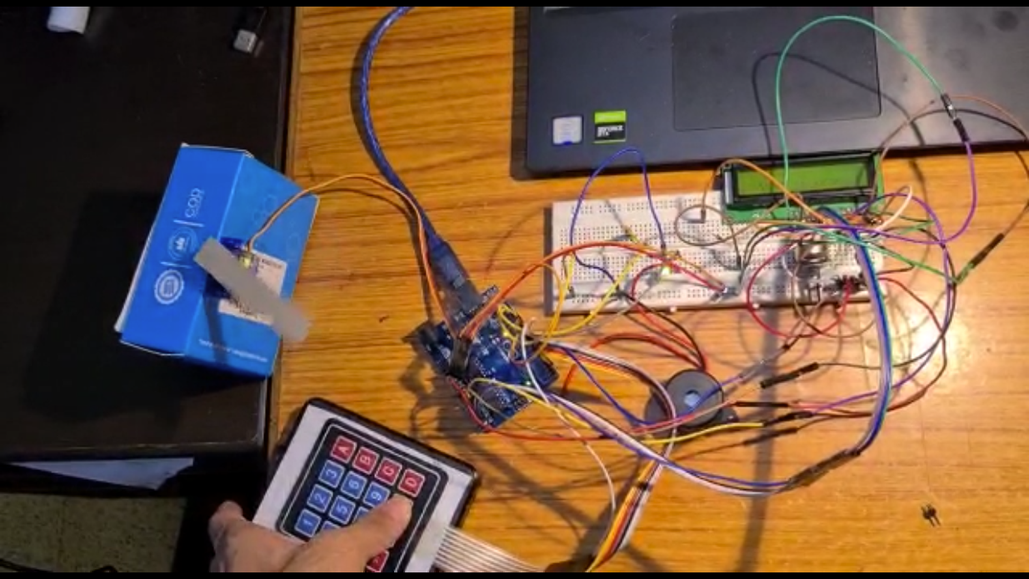

1. **SOFTWARE**

**3.1 CODING & ANALYSIS**

After inserting all the header and library files, assign all the pin for LCD and define the password length and set the initial position of the servo to 0. After that, take a “char” datatype for declaring the number that can hold it including the null character.

Header files:

Keypad.h => Required for handling the 4x4 Keypad

LiquidCrystal.h =>Required for handling the LCD

Servo.h =>Required to handle the Servo Motor

#include <Keypad.h>

#include <LiquidCrystal.h>

#include<Servo.h>

With this piece of code (char Master[Password_Lenght] = "123456";) -- under the Char Master, I declare the password of the door lock, then assign the number of rows and columns in the keyboard and declare keyMaps and connect with rows and columns.

Servo myservo;

LiquidCrystal lcd(A0, A1, A2, A3, A4, A5);

#define Password_Lenght 7

int pos = 0;

char Data[Password_Lenght];

char Master[Password_Lenght] = "123A45";

**Setup Function**

Under the void setup, initialize the servo signal pin D9, servo status closed and print the name of the project/device/company with 3 seconds of delay on LCD time of starting the device.

void setup()

{

  myservo.attach(9);

  ServoClose();

  lcd.begin(16, 2);

  lcd.print(" Arduino Door");

  lcd.setCursor(3, 1);

  lcd.print("-CSE2006-");

  delay(3000);

  lcd.clear();

  pinMode(13, OUTPUT);

}

**Loop Function**

Under the loop function, the simple if-else condition is there. The loop function is executed again and again in a loop. There are 3 conditions: - When,

Door Closed(door=1), which leads to entering the custom key (“*”) for closing the lights or Open () where we have to enter the password.

Door Open(door=0), which leads to entering the custom key (“#”) for closing the Door or Open () where we have to enter the password.

Default choice, leads to the Open () where we have to enter the password.

void loop()

{

  if(door ==1){

    if (customKey == '*'){

      lcd.clear();

       digitalWrite(13, LOW);

      lcd.print("  Lights closed");

      delay(3000);

    }

  }

  if (door == 0)

  {

    customKey = customKeypad.getKey();

    if (customKey == '#')

    {

      lcd.clear();

      ServoClose();

      lcd.print("  Door is close");

      tone(12, 1500, 500);

      delay(3000);

      door = 1;

    }

  }

We have used 2 functions for controlling the Door using the servo motor.

ServoOpen(), rotates the servo to open position as it goes from 180 degrees to 90 degrees , door data count as 1 otherwise door locker remains open and data count 0.

ServoClose(), rotates the servo to close position as it goes from 90 degrees to 180 degrees.

The servo open and servo close functions are shown below.

void ServoOpen()

{

  for (pos = 180; pos >= 90; pos -= 5) {

    myservo.write(pos);

    delay(15);

  }

}

void ServoClose()

{

  for (pos = 90; pos <= 180; pos += 5) {

    myservo.write(pos);

    delay(15);

  }

}

Write the position of the servo with 15 seconds of delay to reach the servo position. Under the void open function, print on LCD “Enter Password” then the condition specifies that the entered password should be same with custom key, within this body data counted and stores char into the data array, incremented and input password printed on LCD if the data length (number of key) and input password matches with Data Master (where the pre-defined keys are present).

Then as an action LCD clear, servo drive, print on LCD “Door is open” and the data counter is reset to 0. If the input key does not match with Data Master, as an action on LCD clear print on LCD “Wrong Password “ to notify with 1 second of delay and remains in its lock position with data counter sets to 1 and continue this process in a loop.

void Open()

{

  lcd.setCursor(0, 0);

  lcd.print(" Enter Password");

  customKey = customKeypad.getKey();

  if (customKey)

  {

    Data[data_count] = customKey;

    lcd.setCursor(data_count, 1);

    lcd.print(Data[data_count]);

    data_count++;

  }

if (data_count == Password_Lenght - 1)

  {

    if (!strcmp(Data, Master))

    {

      lcd.clear();

      ServoOpen();

      lcd.print("  Door is Open");

      door = 0;

      tone(12, 1000, 500);

      digitalWrite(13, HIGH);

      delay(1000);

    }

    else

    {

      lcd.clear();

      lcd.print("  Wrong Password");

      door = 1;

      tone(12, 2000, 500);

      delay(1000);

    }

    clearData();

  }

}

ARDUINO IDE

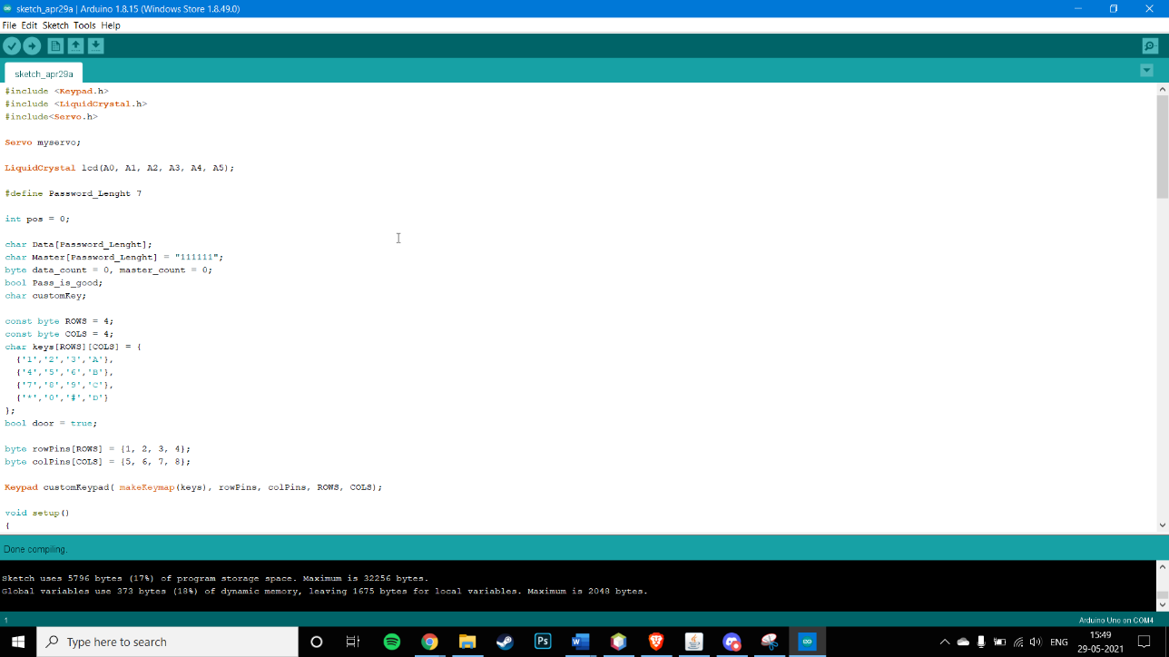

**3.2 FULL CODE:**

#include <Keypad.h>

#include <LiquidCrystal.h>

#include<Servo.h>

Servo myservo;

LiquidCrystal lcd(A0, A1, A2, A3, A4, A5);

#define Password_Lenght 7

int pos = 0;

char Data[Password_Lenght];

char Master[Password_Lenght] = "123A45";

byte data_count = 0, master_count = 0;

bool Pass_is_good;

char customKey;

const byte ROWS = 4;

const byte COLS = 4;

char keys[ROWS][COLS] = {

  {'1','2','3','A'},

  {'4','5','6','B'},

  {'7','8','9','C'},

  {'*','0','#','D'}

};

bool door = true;

byte rowPins[ROWS] = {1, 2, 3, 4};

byte colPins[COLS] = {5, 6, 7, 8};

Keypad customKeypad( makeKeymap(keys), rowPins, colPins, ROWS, COLS);

void setup()

{

  myservo.attach(9);

  ServoClose();

  lcd.begin(16, 2);

  lcd.print(" Arduino Door");

  lcd.setCursor(3, 1);

  lcd.print("-CSE2006-");

  delay(3000);

  lcd.clear();

  pinMode(13, OUTPUT);

}

void loop()

{

  if(door ==1){

    if (customKey == '*'){

      lcd.clear();

       digitalWrite(13, LOW);

      lcd.print("  Lights closed");

      delay(3000);

    }

  }

  if (door == 0)

  {

    customKey = customKeypad.getKey();

    if (customKey == '#')

    {

      lcd.clear();

      ServoClose();

      lcd.print("  Door is close");

      tone(12, 1500, 500);

      delay(3000);

      door = 1;

    }

  }

  else Open();

}

void clearData()

{

  while (data_count != 0)

  {

    Data[data_count--] = 0;

  }

  return;

}

void ServoOpen()

{

  for (pos = 180; pos >= 90; pos -= 5) {

    myservo.write(pos);

    delay(15);

  }

}

void ServoClose()

{

  for (pos = 90; pos <= 180; pos += 5) {

    myservo.write(pos);

    delay(15);

  }

}

void Open()

{

  lcd.setCursor(0, 0);

  lcd.print(" Enter Password");

  customKey = customKeypad.getKey();

  if (customKey)

  {

    Data[data_count] = customKey;

    lcd.setCursor(data_count, 1);

    lcd.print(Data[data_count]);

    data_count++;

  }

  if (data_count == Password_Lenght - 1)

  {

    if (!strcmp(Data, Master))

    {

      lcd.clear();

      ServoOpen();

      lcd.print("  Door is Open");

      door = 0;

      tone(12, 1000, 500);

      digitalWrite(13, HIGH);

      delay(1000);

    }

    else

    {

      lcd.clear();

      lcd.print("  Wrong Password");

      door = 1;

      tone(12, 2000, 500);

      delay(1000);

    }

    clearData();

  }

}

1. CONCLUSIONS

**4.1 CONCLUSION**

The use of the Arduino uno microcontroller in this project allows for design simplicity, hence, the project can be achieved in lesser time compared to other techniques previously employed.

**4.2 FUTURE WORK**

We could also further use these devices for IOT connections and projects.

We would add an ESP-8266 Wi-Fi Module and a Qualcomm Bluetooth Module which would allow us to control the lock through our phones and remotely open and lock the system without the hassles of wires or typing combinations.

We could even improve the password techniques to visual identifications, otp based or pattern based.

We could even setup Alert systems through Messages other than buzzers.

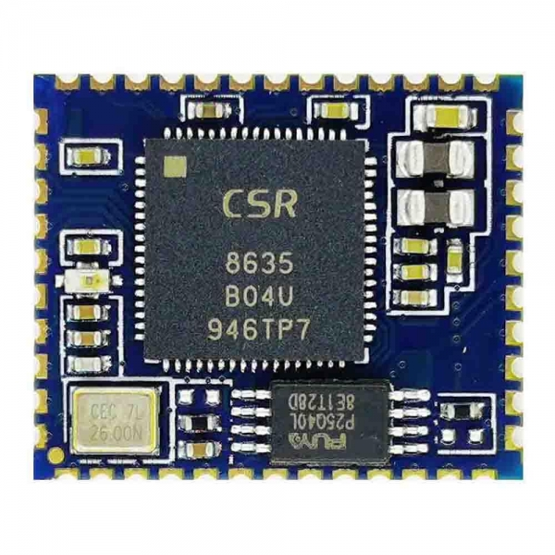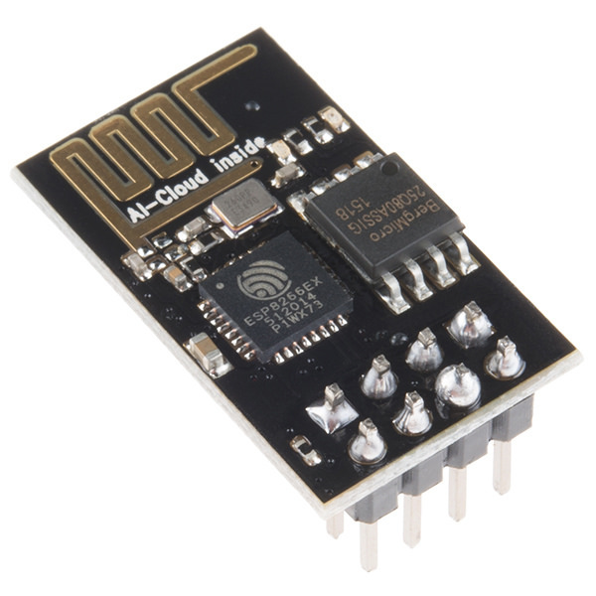

1. **REFERENCES**

* <https://www.researchgate.net/publication/344256856_Automated_Door_Lock_System_Using_Arduino>
* <https://create.arduino.cc/projecthub/SURYATEJA/use-a-buzzer-module-piezo-speaker-using-arduino-uno-89df45>
* <https://create.arduino.cc/projecthub/rowan07/make-a-simple-led-circuit-ce8308>
* <https://lastminuteengineers.com/arduino-keypad-tutorial/>
* <https://www.instructables.com/Arduino-Servo-Motors/#:~:text=Introduction%3A%20Arduino%20Servo%20Motors&text=Servo%20motors%20are%20great%20devices,and%20it%20will%20go%20there>